GETTING DATA IN DATABASE
- Saw data using Postman get request.
- 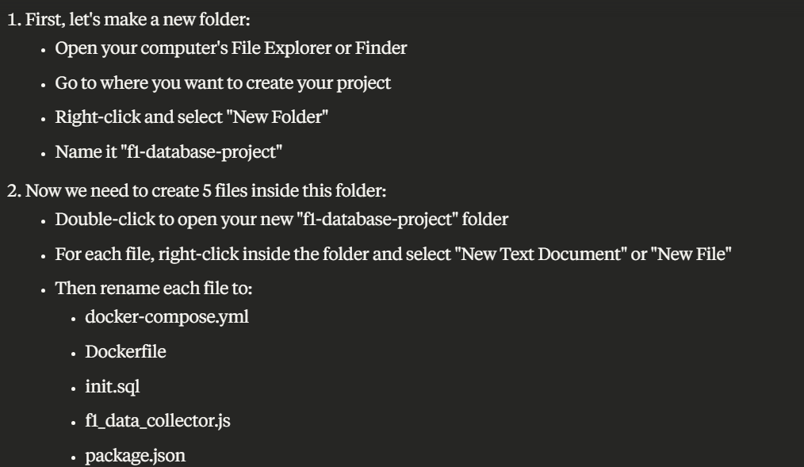
- Paste the data in the respective files
- 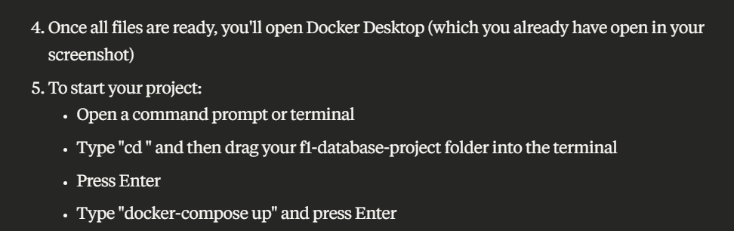
- Open a terminal and navigate to your project directory:
- Build and start the Docker containers: docker-compose up -d
- Check that all containers are running: docker-compose ps
- npm install node-fetch
- Access and View Your F1 Data
- Open your web browser and go to: http://localhost:8080
- Log in to pgAdmin using:
  - Email: user@example.com
  - Password: pgadmin
- Add a new server connection in pgAdmin:
  - Name: F1 Database
  - Connection tab:
    - Host: postgres
    - Port: 5432
    - Maintenance database: f1data
    - Username: f1user
    - Password: f1password
- Click "Save" to connect to your database
- Browse your data:
  - Expand: Servers → F1 Database → Databases → f1data → Schemas → public → Tables
  - Right-click on any table (e.g., "constructors") and select "View/Edit Data" → "All Rows"
- To delete and all via cmd –
  - Step 1- docker exec -it f1-database psql -U f1user postgres
  - Step 2- docker exec -it f1-database psql -U f1user -c "SELECT pg_terminate_backend(pid) FROM pg_stat_activity WHERE datname='f1data' AND pid <> pg_backend_pid();"
  - Step 3-Dropping a DB - docker exec -it f1-database psql -U f1user -c "DROP DATABASE f1data;"
  - Step 4-Creating a new DB - docker exec -it f1-database psql -U f1user -c "CREATE DATABASE f1data;"
  - Step 5- \q

WRITING CODE

- Create new env (conda create -n f1_project_env python=3.9)
- Activate it (conda activate f1_project_env)
- Install (pip install ipykernel) for spyder to use
- Installing libraries
- Open spyder, Go to Tools -> Preferences-> Python interpreter -> Use the following Python interpreter -> (C:/Users/shubh/anaconda3/envs/f1_project_env/python.exe) -> Apply -> OK
- Install libraries (pip install pandas sqlalchemy)( pip install psycopg2-binary)( pip install python-dotenv) (conda install spyder-kernels) (conda list)
- Create env file with (name will be .env)
  - DB_HOST=localhost
  - DB_PORT=5432
  - DB_NAME=f1-db
  - DB_USER=Shubhan
  - DB_PASSWORD=Rishita@28
- Start up the db using (docker-compose up -d)
- Check python file(Data_Ingestion.py) for next steps in getting data into df from various sources in learnings folder.
- For our case we will use the function (get_data_from_postgresql) which uses (get_db_engine)
- Get all three Datasets into DFs

DATA MODELLING

